1. House Rules and Rules of Behaviour
We wish you a warm welcome to Visit Croatia accommodation facilities! To make your stay in our accommodation units comfortable, please come and meet our House Rules and contact the host for any further information.
• Each guest must provide a valid identity card or passport to the host for registration for arrival at the accommodation unit.
• The accommodation unit is charged daily and is available from 14:00 (check in) on the day of arrival until 10:00 (check out) on the day of departure. Retention in the accommodation unit after 10 hours requires an additional charge for the stay without the possibility of further stay.
• Guests are responsible for their behavior in the accommodation facility, in the accommodation unit as well as in the surrounding area, and in the event of an accident they bear the consequences themselves.
• It is forbidden to curb the public order and peace, causing disorder and disturbing other guests. From 23:00 to 07:00 it is the night time, and from 13:00 to 16:00 the time of the afternoon peace and please be kind and do not bother with other guests by creating noise.
• We do not take responsibility for the possible disappearance or loss of your valuables, money or documents.
• It is not permissible to enter easily flammable and explosive substances and substances with a strong or unpleasant odor as well as not to enter electrical consumptions for which you have not received the consent of the host.
• Any malfunction, damage or defect in the accommodation unit, inventory or installations, please notify the host immediately.
• The destruction and removal of inventory from the accommodation facility (cushions, blankets, towels, etc.) is prohibited. For any deliberate or unintentional damage or loss (eg keys), the customer is obligated to compensate for the appropriate counter value.
• Please use rational energy (shut off taps, light up and other electrical consumables). The air conditioner is switched off when the entrance or balcony door is open.
• Pets are allowed with prior arrangement and notice when renting accommodation. Pets are additionally charged.
• Smoking is not allowed in accommodation units.
• Swimming pool use is solely at your own risk. In the event of an accident, the guests themselves bear the consequences. Please responsible behavior.
• The host is entitled to the absence of a guest in special circumstances to enter the accommodation unit in order to prevent possible harm or danger. If the host entered the house, the host is obliged to inform the guest in the first following contact.
• In accommodation units it is possible to receive visitors if they are keeping the House Rules and do not disturb other guests. Otherwise, they will be asked to leave the accommodation unit.
In the case of non-compliance with House Rules, the host has the right to cancel the guest's further provision of the service, with the obligation to settle the entire rental of accommodation by the guest.

2. Stay in Visit Croatia facilities
Does it really look like an accommodation unit like in the pictures?
Visit Croatia guarantees the truthfulness of the images and the data relating to the characteristics of the accommodation units from their offer, as well as the truth of the prices and the conditions under which they are offered.
To whom to turn to the location?
After the advance payment has been made to your reservation, you will receive your confirmation e-mail with your name and surname and the contact number of your host. Contact the host about the details of arrival at the accommodation unit, picking the keys and leaving the accommodation unit.
Will clean towels and bedding wait for me?
Of course. In the rental price of the accommodation are included clean towels and bed linen for as many persons as announced. Bed linen is changed every 7 days, and towels every 4 days. If you need more, please ask the same.
Is the final cleaning of the apartment charged?
Yes, a charge of 20,00 EUR per accommodation unit. A well-known practice in the hotel and catering industry is the collection of final cleaning of the accommodation unit so that the next guests will enjoy the cleanliness and comfort as you are. Charges are charged one time, regardless of the duration of your stay and the number of people. The host is not obliged to clean and clean up during your stay in the accommodation unit.
Can I prepare food in the apartment?
One of the many benefits of a private accommodation over the hotel is that all our accommodation capacities have a fully equipped kitchen for serving and for making comfortable meals.
Do I have the right to use the barbecue?
Of course. Every guest has the right to use the grill. If more guests use a shared barbecue please negotiate on the spot. Each guest is obliged to clean after using the barbecue that it can be ready for the next use.
Can we reserve a baby cot / crib?
A cot / crib can be arranged with the host upon your arrival at the location or arranging in advance when booking accommodation if available. Use is not charged.
Is there internet available in apartments and villages in Visit Croatia?
We are aware of today's needs for internet access and we have equipped our accommodation capacities with broadband internet where it was possible for technical reasons. The internet is not charged extra.
Lost (s) the key of the apartment?
You are required as soon as possible to report lose the keys to the host. The cost of replacing locks and making new keys is payable by the guest, without delay, in the amount of EUR 50.00.
My dog ​​is my family. Do I and him?
In all Visit Croatia accommodation facilities across the Adriatic, pets are allowed for a fee of EUR 10 per day.

3. Arrival and departure
How to get to the apartment?
The easiest way to get to our accommodation facilities is with Google Maps. However, if you are not able to find our accommodation facility, you may contact host you mentioned on your Booking Confirmation.
Who will give me the keys to the apartment?
One of our hosts who is in charge of the accommodation facility in which you are staying will hand over the keys, take the identification information and, if necessary, make a payment.
Is there a possibility that someone else takes over the keys?
There is possibility. The key does not have to be taken by the person who is the bidding party. It is possible that the key is taken over by the person who is also a guest in the stay with the bidder. Upon arrival, any guest needs to take the data from the personal documents.
How many hours can I get / leave the apartment?
Regular entrance to the accommodation unit (check in) is from 14:00 hours on day of accommodation service, and check out for 10:00 hours. Visit Croatia is not obligated to receive guests before 14 hours.
However, early entry into the accommodation unit is possible if there are no guests before and if the accommodation unit is ready for your stay. In such cases, it is best to contact the contact person / host listed on your booking confirmation the day before arrival and check if such a possibility exists.
On the day of departure, the guest is obliged to allow the host a review of the status of the hired accommodation, and hand it over in the condition he has found on the day of arrival. Upon departure, the host checks the accommodation unit and retains the right damages to be compensated. If you do not leave the accommodation unit until 10:00 h Visit Croatia reserve the right to charge one more day.
Arrival early in the morning or late night hours?
In the spirit of the true host, the Visit Croatia host will welcome you at any time of the day or night, of course with a prior notice of your arrival time (if arriving by car) or the expected arrival time at the destination bus / train station or airport. For such cases, only coordination / communication between you and the host of Visit Croatia is important for you to accommodate your accommodation unit and allow you to rest after your journey as soon as possible at your desired destination.
To whom do I provide keys at the end of my stay?
Keys are handed over to Visit Croatia's host, after controlling the accommodation unit. There is a possibility to leave at a previously agreed place.
What if I want to extend or shorten my stay?
If you would like to extend your stay, please inform the host in due time in order to check if it is possible. It is possible if the same or similar accommodation unit is free.
In the case of a shorter stay than the reservation you have to settle the entire rental amount. Refunds of paid funds can not be made.

4. How to book accommodation?
Book your accommodation:
• sending an e-mail
• directly on the website
• by calling a mobile phone
We prefer sending an e-mail so that we can present our accommodation facility in detail. Very simply after checking the availability you can also book in the form on our web site.
Prices of accommodation units are displayed on Visit Croatia page and refer to daily rent. The prices are quoted in foreign currency (EUR) and are informative and based on the currency and foreign currencies (EUR). Visit Croatia reserves the right to change these prices and may deviate from market and monetary changes.
What do all rental prices cover?
If the accommodation unit / unit possesses, the price includes the following:
• stay in the accommodation unit
• electricity costs
• gas costs
• water costs
• the cost of the internet
• cost of cable or satellite TV
• parking
• air-conditioning unit **
• kitchen inventory
• barbecue

** Air-conditioning
If the air conditioner is switched on and the windows are open when the guest is in or is not in the booked accommodation, Visit Croatia reserves the right to charge for the negligent use of the air conditioner, which increases the price of 4,00 EUR per day. The rules for using the air conditioner are listed in the Operating Instructions for the air conditioner in each accommodation unit.

Additional charges apply:
• tourist tax
The tourist tax prescribed by the Law on Tourist Tax of the Republic of Croatia amounts from 2.50 to 8.00 kn per person per day for adults. Persons aged 12 to 18 have a 50% discount on this amount, while persons up to 12 years of age are exempted from paying Tourist tax. The final amount of the Tourist tax for a specific reservation depends on the location and the term of stay and is charged according to the General Terms and Conditions and at the same time with the payment of the total amount for the accommodation.
• final cleaning after your stay
In addition to the above stated price, the final cleaning fee is additionally charged. Final cleaning of the accommodation unit is done on the day of arrival and / or departure from our host. The price is 20 - 80 EUR depending on the size of the accommodation unit. The guest is obliged to leave the accommodation accurately. Cleaning the kitchen utensils before departure as well as throwing garbage is a guest's obligation.
• pets
When prompted, it is necessary to specify the type, breed and size of the pet. Pet fee is 10 EUR per day. It is not allowed to leave a pet alone, without the owner's supervision. In the event that your pet carries out any material damage to one of our accommodation units, the pet owner is obliged to pay the damage without delay.
If you did not informe a host about pet at booking, Visit Croatia reserves the right to cancel your reservation upon your arrival and without having to pay back the funds you paid.
• extra bed
Use of the extra bed is required when booking the unit and costs EUR 10 per day.

5. Terms and Conditions of Payment and Payment
Payment has to be made to a transaction account opened at Zagrebačka banka d.d.
IBAN: HR6723600001102393591
SWIFT (BIC): ZABAHR2X

To make payment on our account properly, you need the following information:
▪ Payer: (name and surname of the payer / holder of the reservation with the address of the dwelling)
▪ Recipient:
Krula d.o.o.
Rudeška cesta 142
10 000 Zagreb
▪ Call Number (Your Offer Number)
▪ IBAN: HR6723600001102393591
▪ Payment Description "Payment by Offer Number (Your Bid Number)"
An example of a properly filled out payment order:

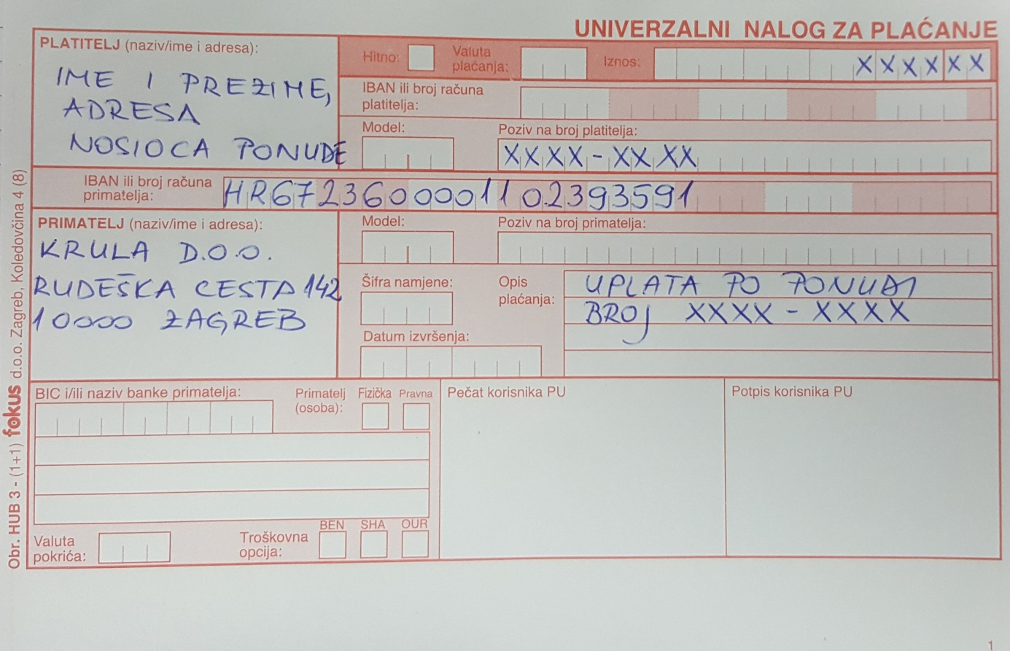

Do I have to make an advance payment to make my booking secure?
Your accommodation request does not mean the accommodation is reserved for you!
Advance payment is a percentage of the price charged by the guest before the arrival, and later this amount is deducted from the remaining amount for the bill. Advance payment is a payment by which the guest confirms their intention and the readiness to arrive at the required accommodation. It is also an additional security and guarantee for the guest, which obliges the service provider / host to guarantee the rented accommodation in the required time. Also, there is the purpose of motivating a guest to come and not allow the paid advance to fail for any reason.
The advance payment service provider primarily means the confirmation of the severity of the guest's reservation.
To book accommodation, you must pay 30% of the total accommodation price in order to make your reservation official. The cost of sending the deposit is borne by the guest. The deposit is required to be paid until the due date of the offer or the automatic offer is canceled and we are free to offer this accommodation to the other guest, and the advance payment is not a reservation.
Upon payment of the deposit, the guest fully accepts the program and the conditions for providing the accommodation are hereby specified.
Can I pay in euros or some other foreign currency?
If the payment is made in the Republic of Croatia, the payment has to be made in HRK according to the valid kuna price list. If payment is made abroad, payment is made in EUR.
Can I pay at the end of my stay?
After the advance payment has been paid, you can pay the remaining amount before arrival or during your stay in the accommodation unit with proof to the host that you have settled the debt.
Who has the right discount?
For the time being, the employees of the Croatian Forests for the total amount of rented accommodation are granted a 10% discount with the possibility of paying a 6-month salary suspension.
Do I send a payment receipt to be safe?
The guest is obliged to submit a receipt on the payment at the e-mail info@visit-croatia.eu. Otherwise, Visit Croatia is not liable for unenforceable reservations due to the delay of the guest in the delivery of the certificate according to the agreed time.
Cancellation of guest reservation?
In case the guest wishes to change or cancel the reservation made on his request, he must do so in writing (by e-mail or by mail). Changing is considered to change the number of persons or the date of commencement and / or termination of service use at least 30 days prior to the commencement of use. The first change of reservation, if possible, will be made free of charge. In the event that a booking change is not possible, and if the guest renounces the confirmed reservation, the cancellation conditions below apply. Changing the accommodation unit and any change within 30 days prior to the reservation and during booking is considered as cancellation of the reservation.
In the situation of a cancellation of a fixed reservation, the date of receipt of a written cancellation is the basis for calculating the cancellation costs as follows:
• for cancellation of 60 days and more days until the beginning of the service or the agreed upon arrival of the guest Visit Croatia guarantees the refund of the paid amount of the advance. Visit Croatia offers the possibility to keep an advance with its validity and usability for a future reservation.
• for cancellation of the reservation from 60 to 30 days until the beginning of the service or the agreed upon arrival of the guest Visit Croatia guarantees a refund of 50% of the paid amount of the advance
• for cancellation of the reservation from 30 days to the beginning of the service or the agreed upon arrival of the guest Visit Croatia does not make a refund of the paid amount of the advance, ie the guest is obliged to pay in full the total amount of accommodation from the reservation
• In case of absence of a guest, Visit Croatia is not able to refund the amount of the deposit paid and the guest is obliged to pay the full amount of the reservation
If the guest in the booked accommodation unit does not arrive at midnight on the day of the commencement of the service and did not inform the Visitor's staff in a timely manner, the reservation is considered to be canceled and the cancellation costs are calculated according to the above. If a guest who fails finding a new user for the same reservation, Visit Croatia will charge only the actual costs caused by the replacement.
The cost of the advance payment is borne by the guest.
Cancellation by Visit Croatia?
Visit Croatia reserves the right to change reservations if there are exceptional circumstances that can not be foreseen, avoided or eliminated. Reserved accommodation can be replaced only by prior notice to the guest and by accommodation of the same or more categories and at the price of the accommodation upon which the guest confirms the reservation.
If replacement accommodation is only possible in a multi-category facility and at a price higher than 10% of the price of the booked reservation, Visit Croatia reserves the right to charge the difference in price upon consultation with the guest. In the event of the inability to change the paid accommodation, Visit Croatia reserves the right to cancel the reservation upon prior notice to the guest before commencing use of the service and warrants a refund of the amount paid regardless of the number of days until the reservation itself.
In this case, the cost of the refund is borne by Visit Croatia.

6. Complaints
Complaints should be announced when the problem arises, Visit Croatia will not accept any complaints at the time of departure to reduce the rental bill. Please report any inconvenience and complaint at time, e-mail info@visit-croatia.eu or host on-site to try to solve them for mutual satisfaction.

7. Resolving the complaint
Each guest - the bidding bider has the right to complain about the unpaid contracted service. If the services are incomplete or poorly executed, the guest may request proportional damages by enclosing the written complaint.
Procedure relating to the objection:
- If the guest at the destination is not satisfied with the situation, he / she is obliged to inform the host immediately upon arrival on the reasons of his dissatisfaction and to notify Visit Croatia in writing to e-mail info@visit-croatia.eu . If a guest does not accept the solicitation of a complaint in response to a reserved and paid service, Visit Croatia will not accept any subsequent claim nor will it be required to respond to it.

- If the guest is not satisfied with the situation and leaves the facility and finds another accommodation in the same place, and that Visit Croatia does not give the opportunity to remove the cause of his dissatisfaction or to find replacement accommodation possibly such a guest can not claim a refund regardless of whether his reasons were justified or not.

8. Personal Data Protection
Guest personal information is provided voluntarily. Guest personal details are required in the process of realizing the required service. It will also be used for further mutual communication. Visit Croatia undertakes not to provide personal information to a third party, except for the purpose of realizing the requested service. The personal data of the guest will be kept in the database, in accordance with the decision of the Management Board on the manner of collecting, processing and keeping personal data. The guest agrees that his personal information may be used for the purpose of marketing campaigns Visit Croatia.

